1. Process: Examination Process
2. Purpose: Conduct internal and external examinations
3. Screens in this process

|  |  |  |
| --- | --- | --- |
| **Screen Name** | **Purpose** | **Access By User Role** |
| Publish Exam Schedule | Maintain exam schedule for internal and final theory exams | For Internal exams: Exam Dept. in college. For final exams: Exam dept. in University |
| Print College Wise Exam Schedule | Print the schedule of internal exams in college | Exam Dept. user in College  Exam Dept. user of Univ. can also view |
| Enter Midterm marks | Enter midterm exam marks | Course teacher |
| Auth Midterm Marks | Authorize midterm exam marks | College AD |
| Enter class record marks | Enter class record marks | Course teacher |
| Auth class record marks | Authorize class record marks | College AD |
| Enter Practical Marks | Enter practical exam marks | Course teacher |
| Auth Practical Marks | Authorize practical exam marks | College AD |
| Print Midterm/class record Marks List | Print report of marks internal exams | Course teacher |
| Marks Authorization Status Report | See the status of marks entry/authorization by various colleges | University Exam Dept. user |
| Maintain Exam Halls | Maintain exam halls in college for final theory exams | College Exam Dept. user |
| Assign Invigilators | Assign invigilators for final theory exam | College AD |
| Print Invigilators List | Print list of invigilators | College AD |
| Make seating arrangements | Make seating arrangement for final theory exam in college | College Exam Dept. user |
| Print Seating arrangement | Print seating arrangement | College Exam Dept. user |
| Fill Exam Attendance | Fill exam attendance | Invigilator |
| Print Exam Attendance Form | Print exam attendance form | College Exam Dept. user |
| Print Exam Attendance Report | Print exam attendance report | College Exam Dept. user |
| Disciplinary Action for Unfair Means | Take Disciplinary Action on student for Unfair Means | University DR |
| Allocate Evaluator / Moderator | Allocate Evaluator / Moderator for final theory exam | University Exam Dept. user |
| Encode Answer sheets | Encode answer sheets | University Exam Dept. user |
| Print Encoded Student List | Print Encoded Student List | University Exam Dept. user |
| Search Encoded Students | Search Encoded Students | University Exam Dept. user |
| Enter Theory Marks | Enter Theory Marks at CAP center | Evaluator & Moderator |
| Authorize Theory Marks | Authorize Theory Marks | Cap center head |
| Moderator Marks Difference Report | Print Moderator Marks Difference Report | Cap center head |
| Enter historical marks | Enter historical marks (marks of examinations in the previous years) | University DR |
| Enter Experimental Course Marks | Enter Experimental Course Marks | University DR |

4.1 Publish Exam Schedule (screen 1)

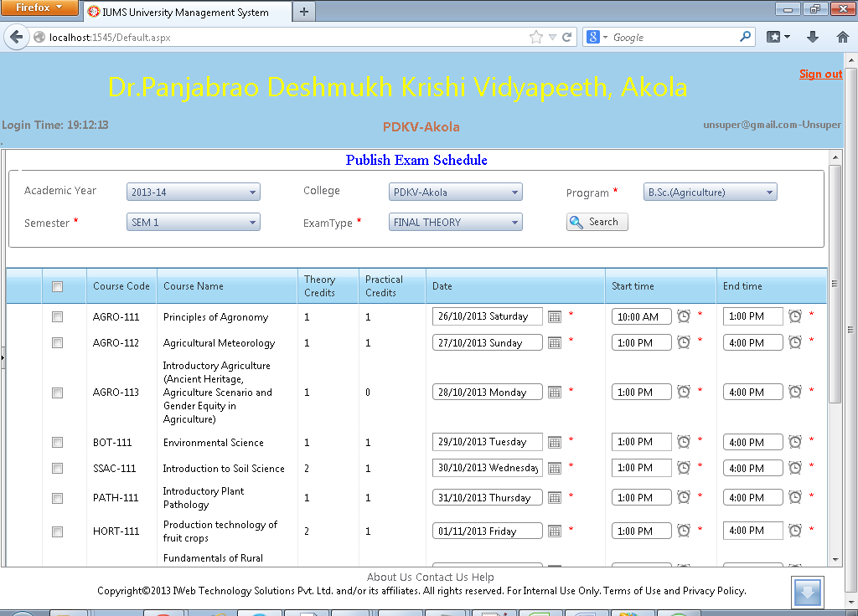

Screen Operation: When setting up schedule for an internal exam, the College Exam Dept. user can use this screen. Select academic year, program, semester & exam type. The College will be pre-selected and cannot be changed. When clicked on Search, the list of courses for the selected program/semester will be displayed. Set the Date and Start time, End time against each course. Finally click Save button.

When setting up schedule for Final theory exam, the University Exam Dept. user can use this screen. The operation is same as above.

Publish Exam Schedule (screen 2)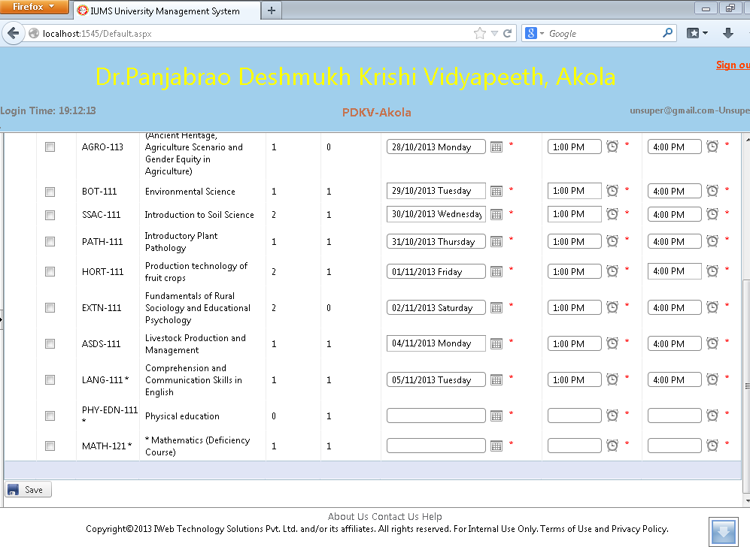

4.2 Print College Wise Exam Schedule

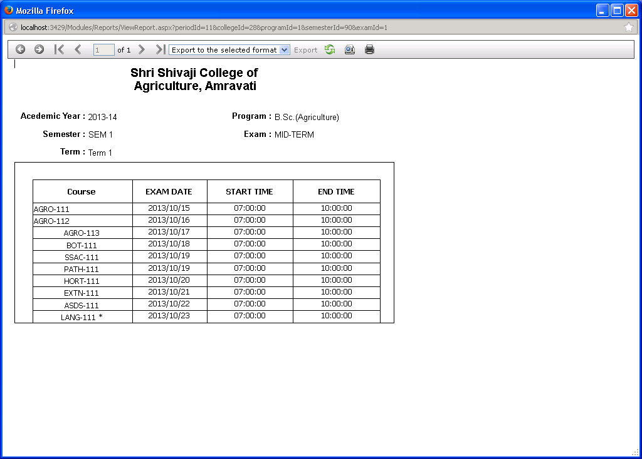

Screen Operation: Select academic year, program, semester and exam type. Click on Print button.

The schedule of exams for all the courses of selected program/semester will be printed.

4.3 Enter Midterm marks

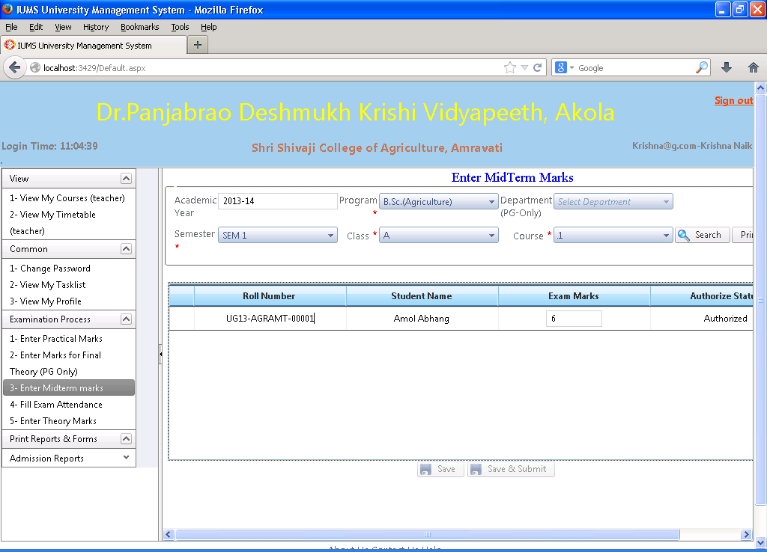

Screen Operation: Select the academic year, program, semester, Class and Course. Click on Search button. The list of students who are registered for the selected course will be displayed. Input the marks in the textbox under column Exam Marks. Click on Save button to save the data. Click on the Print button to print the list of marks input for the selected course.

Save button: Use this button to save the data first time. After this you can take a printout, check the marks and if there is any mistake, you can again edit the marks.

Save & Submit: Use this button finally after making any corrections in marks. Once Save & Submit is done, marks cannot be edited again. This is final marks entry.

Enter Midterm marks (Print)

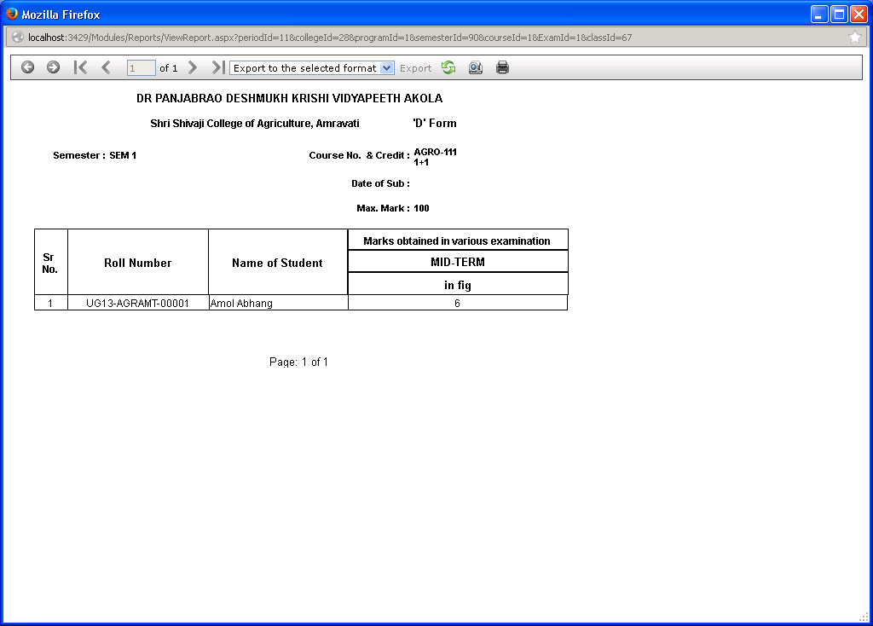

When Print button is clicked, the above report will be displayed in a separate window. Click on the Printer icon to print the report.

4.4 Authorize Midterm Marks

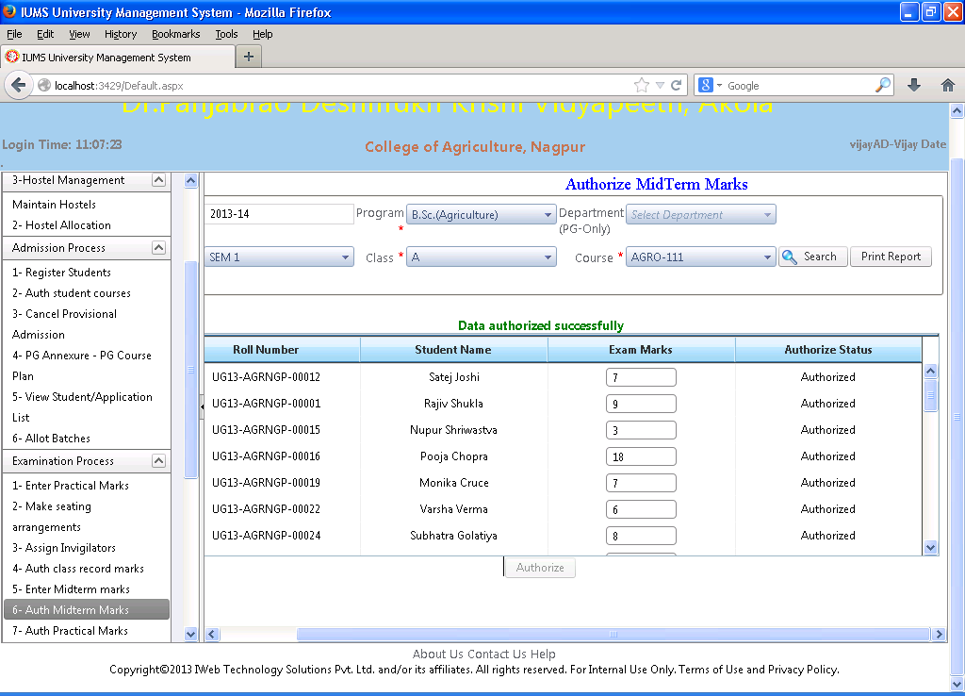

Screen Operation: Select academic year, program, semester, class and course. Click Search button.

The list of students who are registered for this course along with the marks given to them by the course teacher will be displayed. The authorize status is also displayed in the last column.

Click the Authorize button to authorize the marks. This will make all the displayed students marks as Authorized.

Auth Midterm Marks (Print)

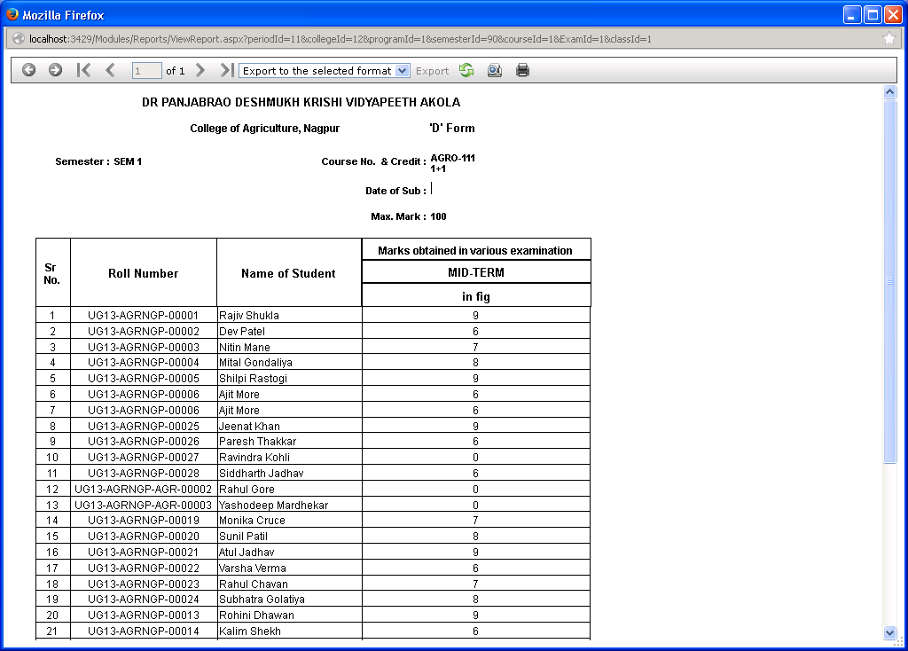

4.5 Enter class record marks

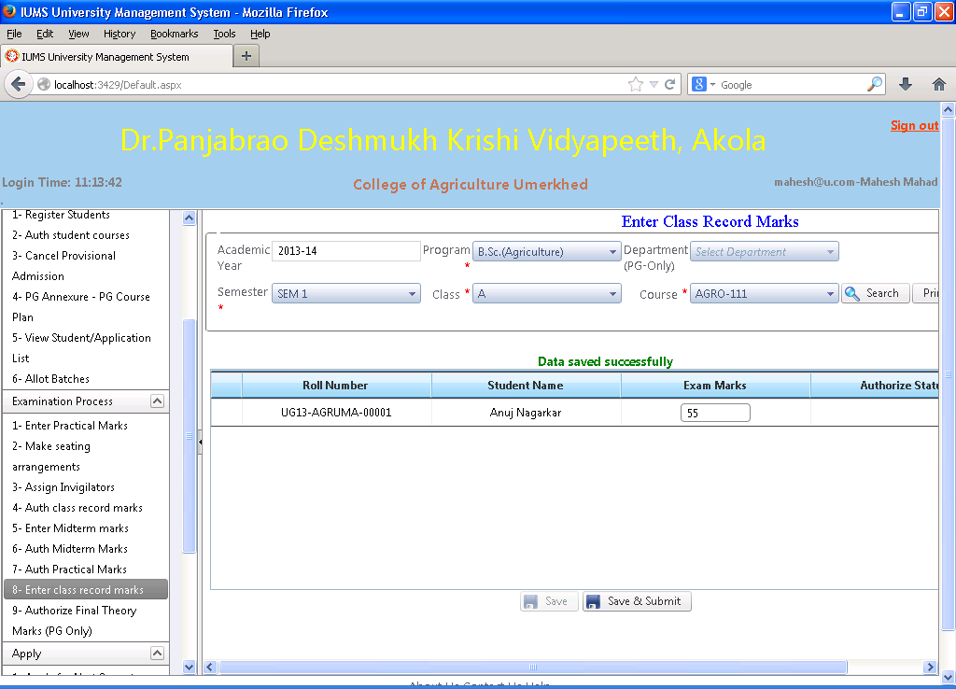

Screen Operation: Same as “Enter Midterm Marks” screen in section 4.3

Enter class record marks(Print)

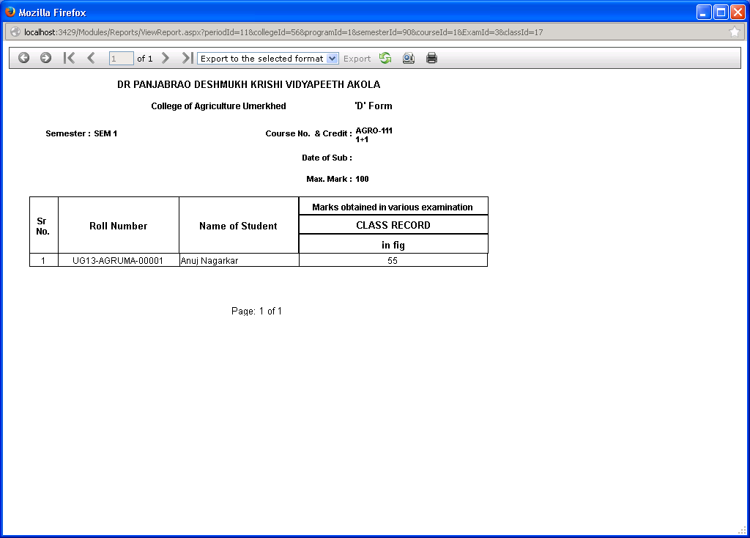

4.6 Authorize class record marks

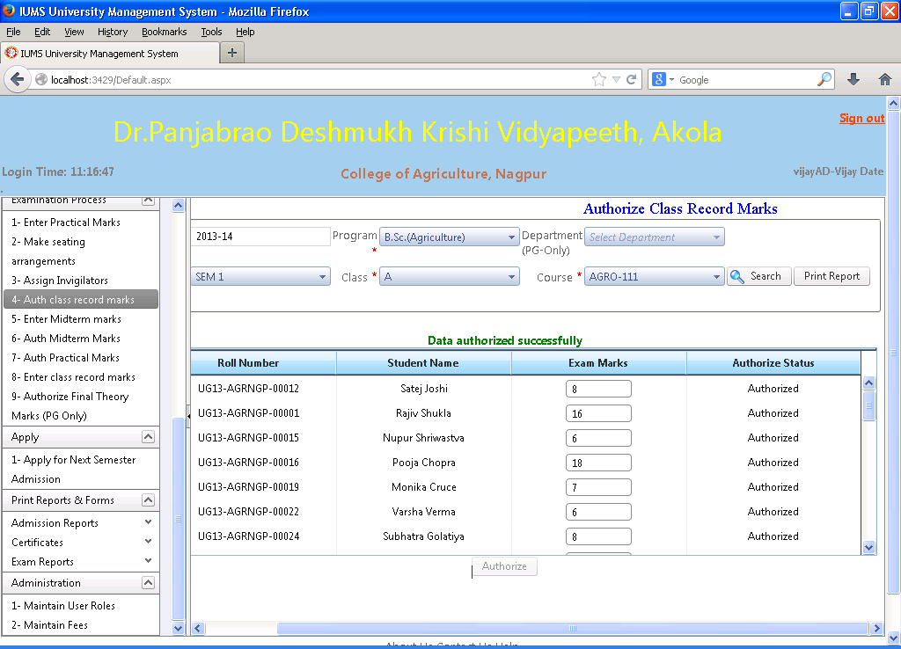

Screen Operation: Same as screen ‘Authorize Midterm marks’ in section 4.4

Auth class record marks(Print)

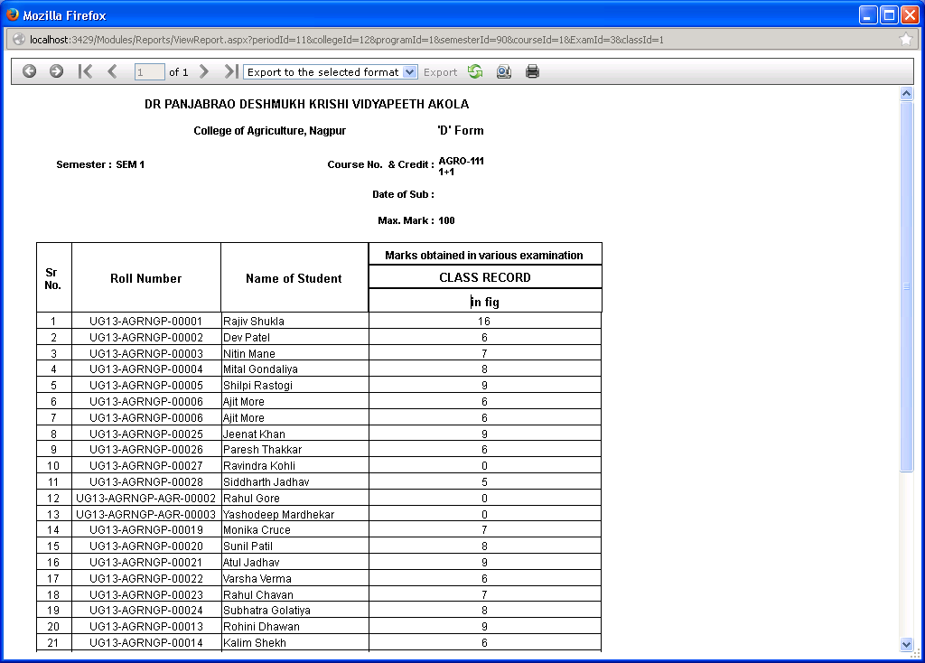

4.7 Enter Practical Marks

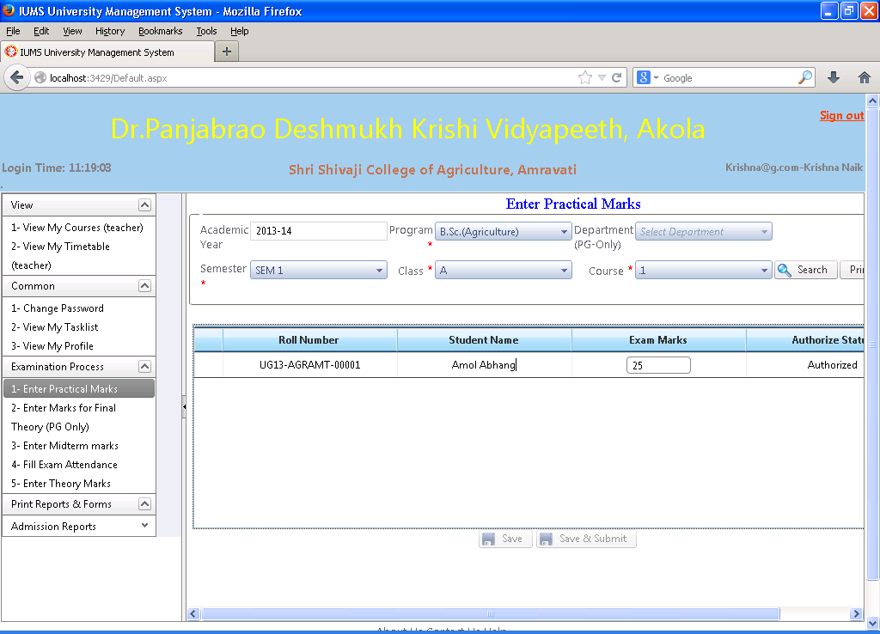

Screen Operation: Same as screen ‘Enter Midterm marks’ in section 4.3

Enter Practical Marks (Print)

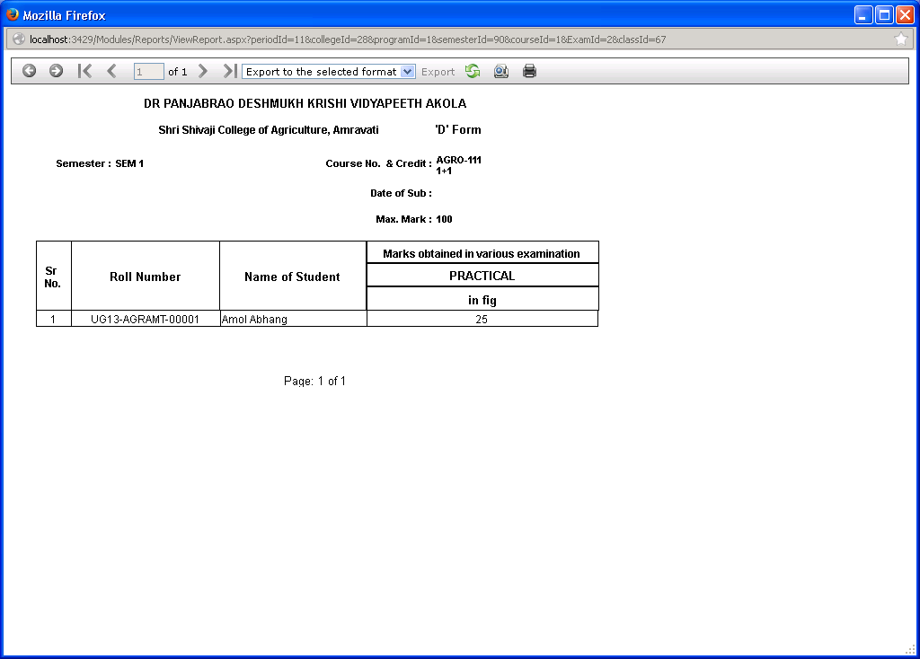

4.8 Authorize Practical Marks

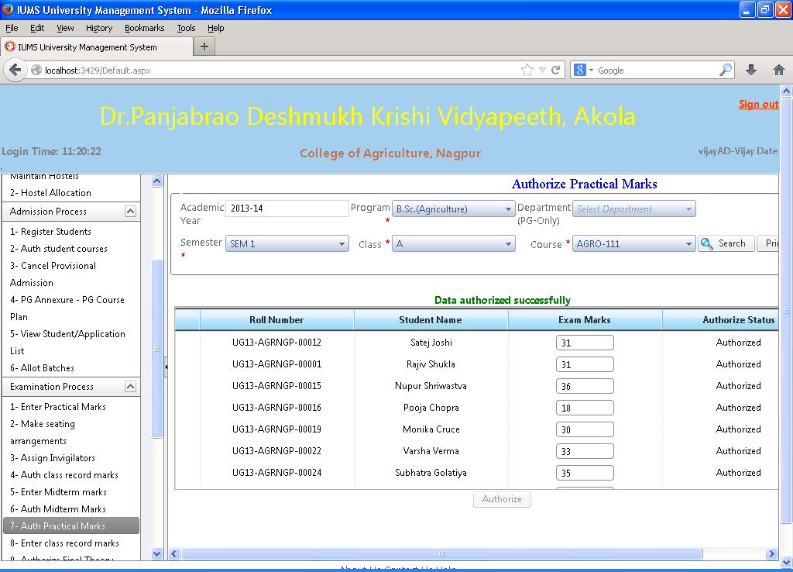

Screen Operation: Same as screen ‘Authorize Midterm Marks’ in section 4.4

Auth Practical Marks (Print)

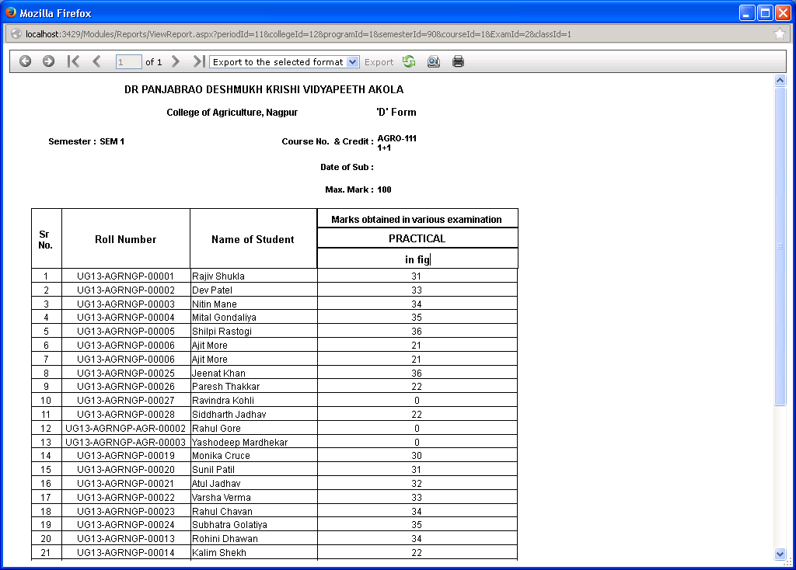

4.9 Print Midterm/class record Marks List



4.10 Marks Authorization Status Report

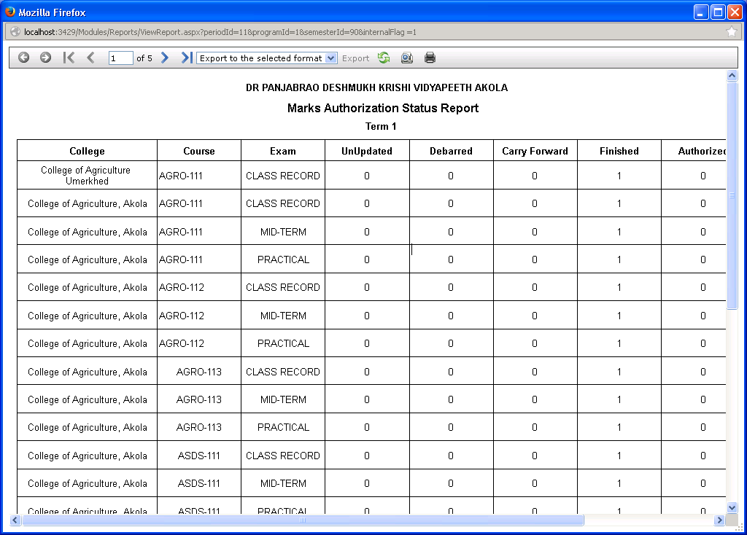

This report can be printed by University exam dept. to check whether all the colleges have made marks entry and authorized it. When Print button is clicked, the report is displayed in a separate window. Click on the Printer icon to print the report.

4.11 Maintain Exam Halls

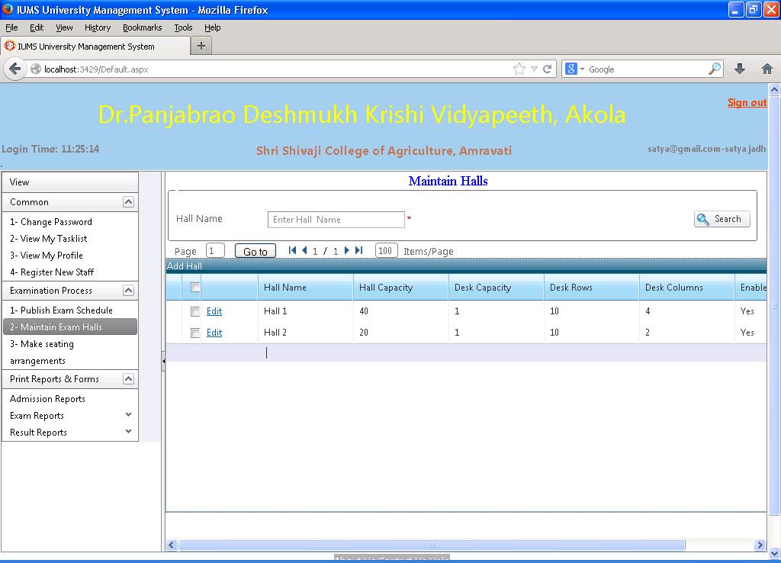

Screen Operation:

Input the hall name and click on Search button. The list of halls with matching name will be displayed, showing hall capacity, desk capacity, desk rows & desk columns. Click on the Edit link in the grid to change the hall properties.

To add a new hall, click on the Add Hall link. A new record will be inserted in the grid, in which you can input the hall name and other properties of the hall.

4.12 Assign Invigilators

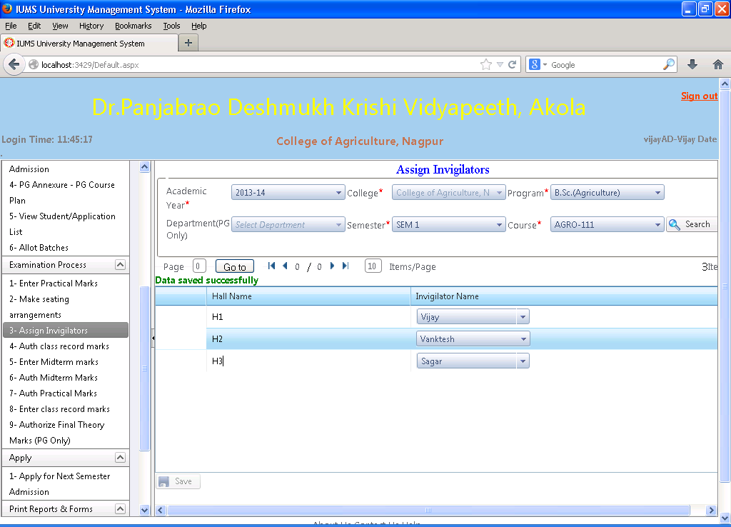

Screen Operation: Select the academic year, program, semester and course. Click on Search button.

The list of exam halls in the college will be displayed. Select the name of the invigilator for each hall from the invigilator list. (The invigilator list is the list of faculty in the college who are assigned an additional role of invigilator by College AD).

Click on Save button to save the data.

4.13 Print Invigilators List

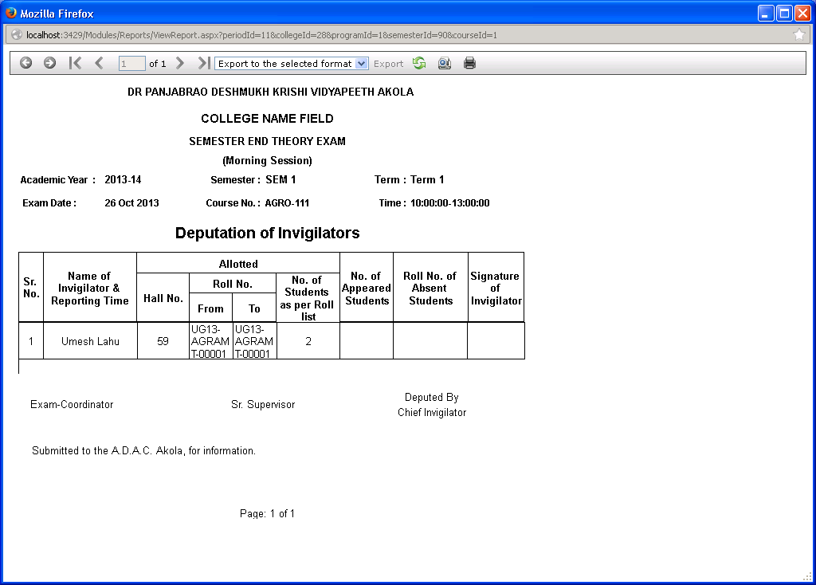

When Print button is clicked, the report is displayed in a separate window. Click on the Printer icon to print the report.

4.14 Make seating arrangements

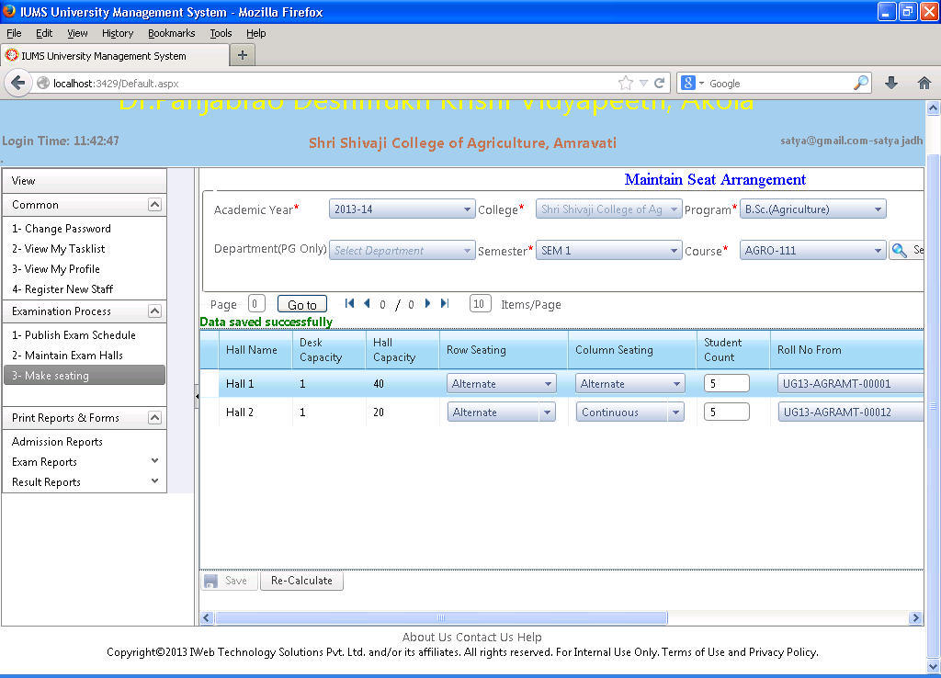

Screen Operation: Select the academic year, program, semester and course. Click Search button. The list of exam halls in the college will be displayed along with desk capacity and hall capacity. Select seating method (alternate or continuous) for Rows & Columns. Select the Roll No. From & Roll No. To from the lists. The total number of students will be calculated and displayed in the Student Count column. Click on the Save button to save the data.

4.15 Print Seating arrangement

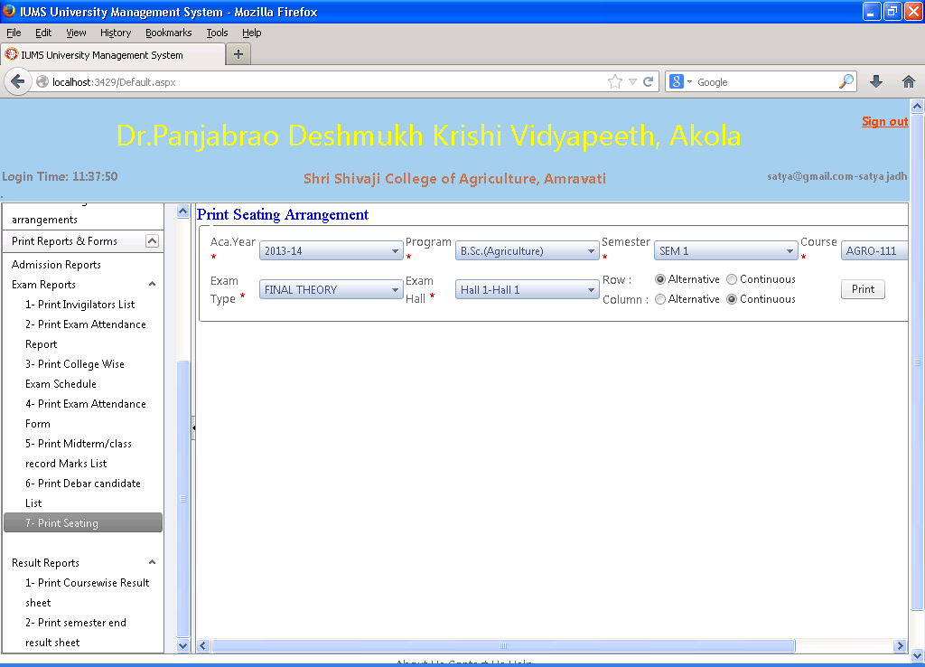

Screen Operation: Select academic year, program, semester, course, exam type and Exam Hall. Select seating arrangement type (alternate or continuous) for Rows and Columns by selecting the appropriate radio button. Click on Print button. The seating arrangement will be printed as per the input given in the previous screen (section 4.14)

Print Seating arrangement (Report)

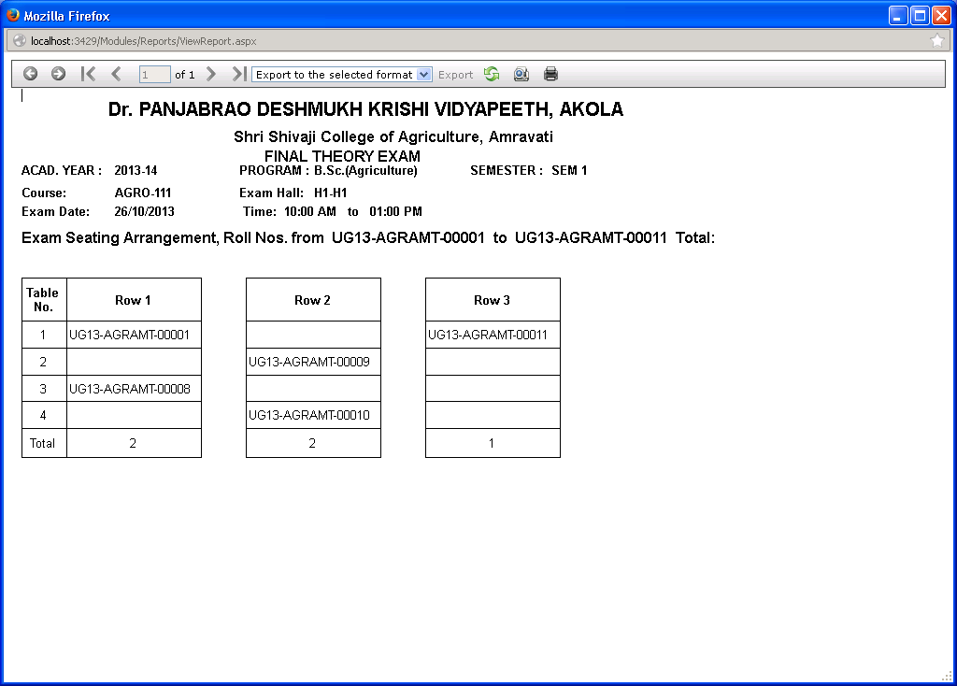

When Print button is clicked, the report is displayed in a separate window. Click on the Printer icon to print the report.

4.16 Fill Exam Attendance (Upper Half)

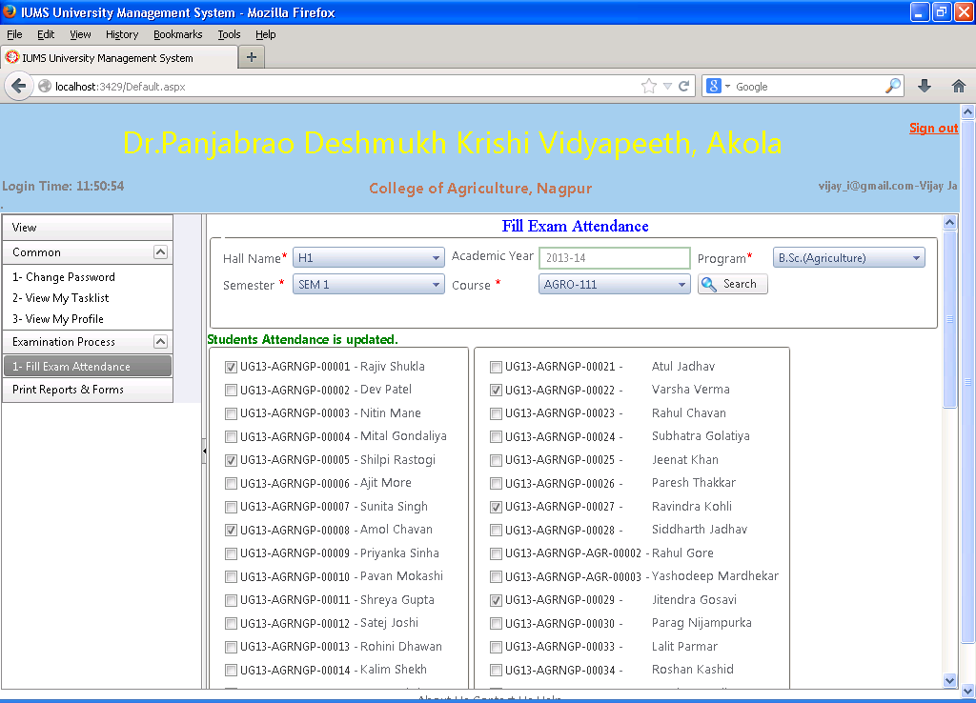

Screen Operation: Select academic year, program, semester, course and Hall name. Click Search button. The list of students allotted to the selected exam hall will be displayed. Check the checkbox against the students who are ABSENT. The unmarked students will be assumed to be present. Click on the Save button to save the data.

Fill Exam Attendance (Lower Half)

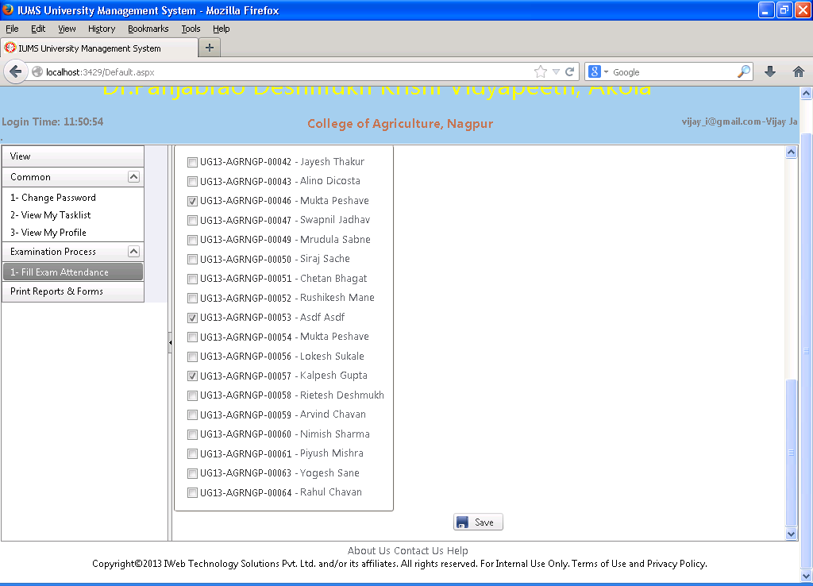

4.17 Print Exam Attendance Form

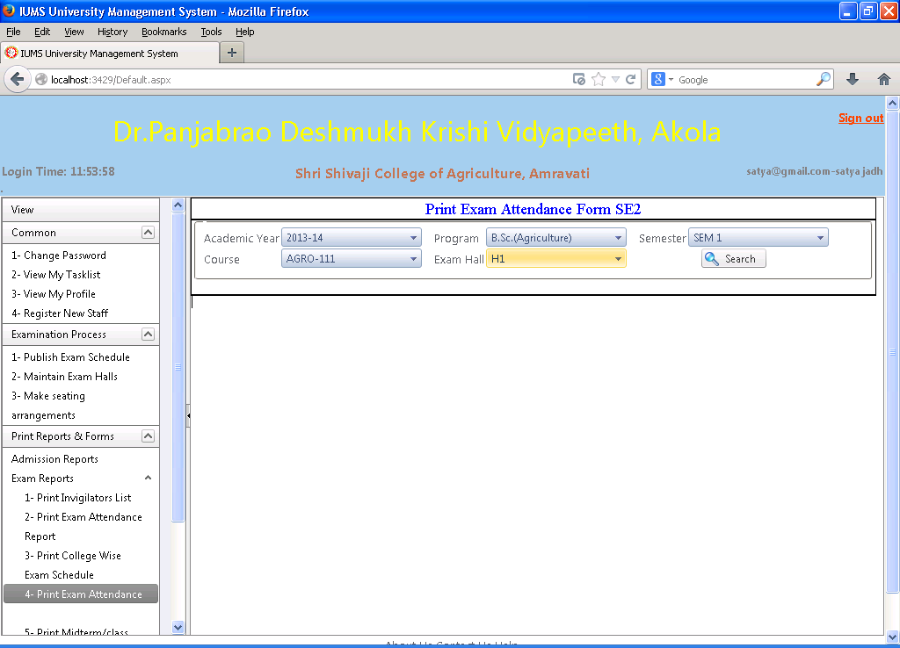

Screen Operation: Select the academic year, program, semester, course and exam hall. Click on the Search button. The report Statement of Attendance will be printed.

Print Exam Attendance Form (Report)

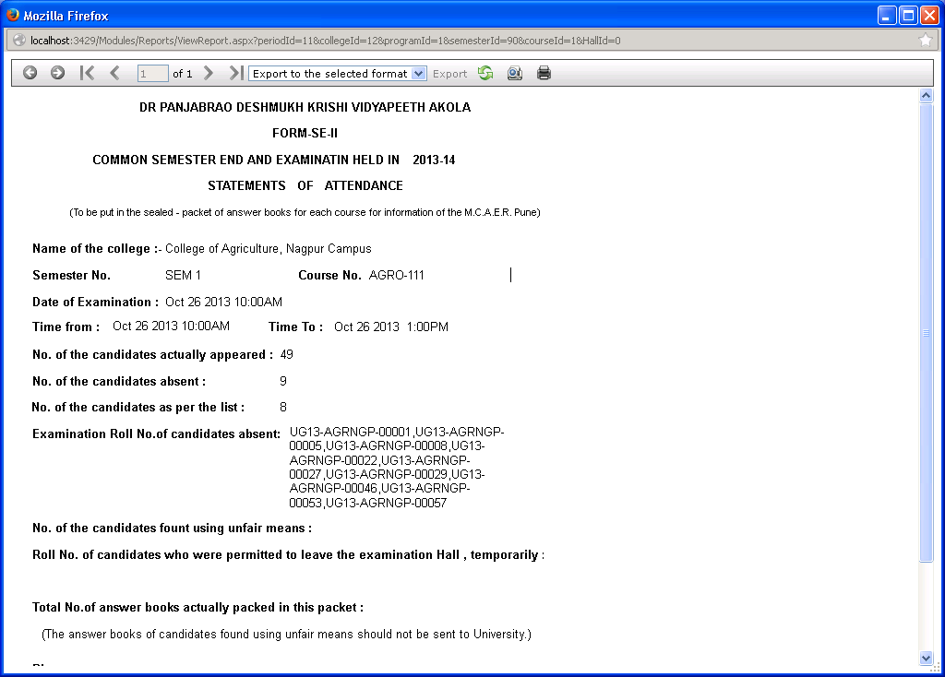

When Print button is clicked, the report is displayed in a separate window. Click on the Printer icon to print the report.

4.18 Print Exam Attendance Report (Screen)

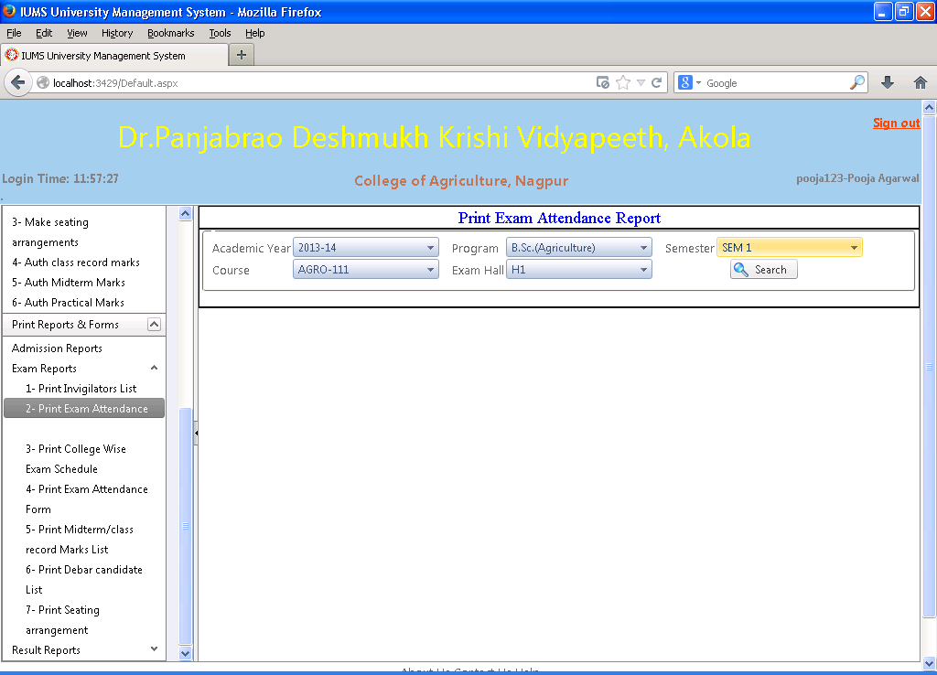

Screen Operation: Select academic year, program, semester, course and exam hall. Click Search button.

The report of exam attendance will be shown in a separate window. Click on Print button to print it.

Print Exam Attendance Report

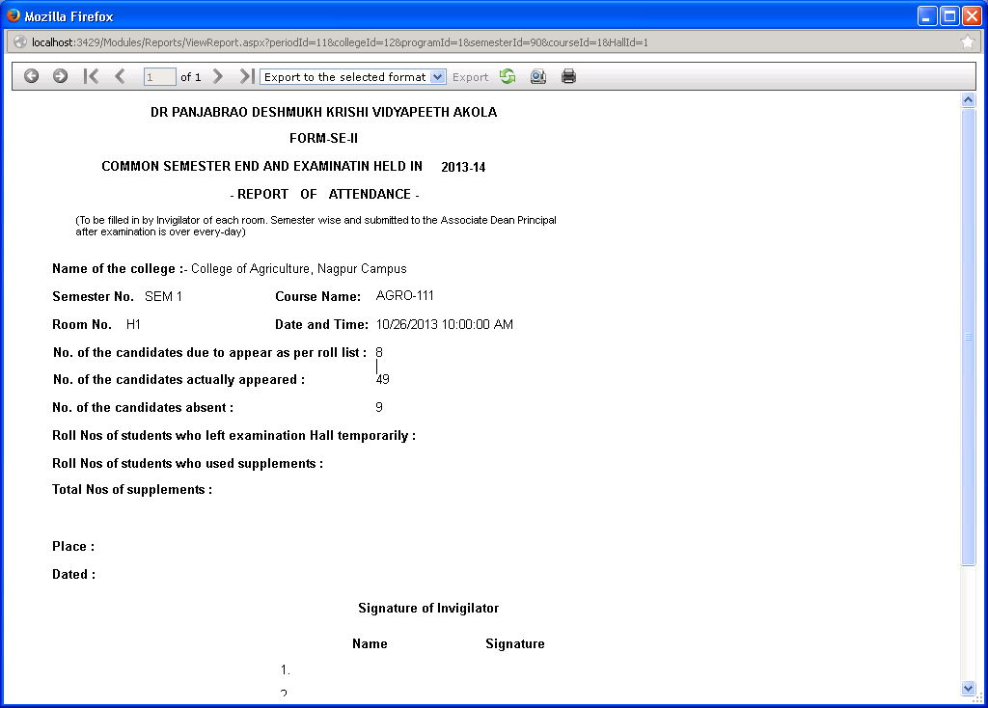

When Print button is clicked, the report is displayed in a separate window. Click on the Printer icon to print the report.

4.19 Disciplinary Action for Unfair Means

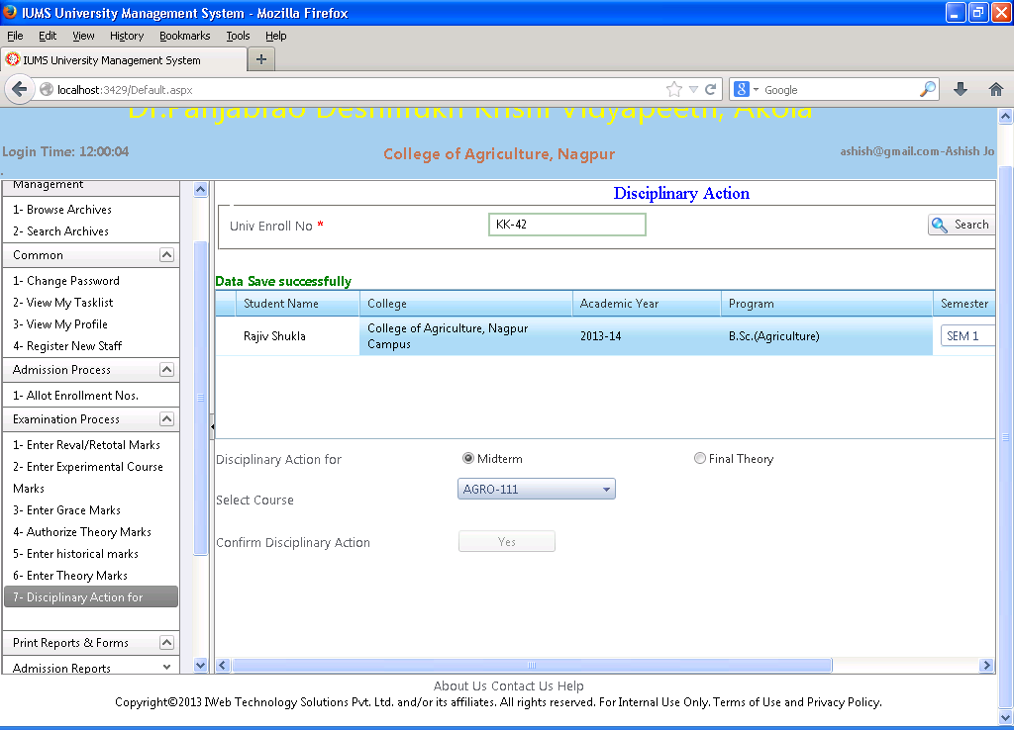

When a student is reported for having adopted unfair means during an examination, the University DR is can apply the penalties to the student as per the regulations using this screen.

Screen Operation: Enter the enrollment number of the concerned student. Click on Search button. The name/college/program of the student will be displayed. Select the semester for which action is to be initiated. Select the exam type (midterm or final theory) in which the student was caught while unfair means by clicking the appropriate radio button. Select the course. Click on the Yes button to confirm disciplinary action. Depending upon the type of exam, the student will be failed in one (for midterm) or all (final theory) subjects of the selected semester.

4.20 Allocate Evaluator / Moderator

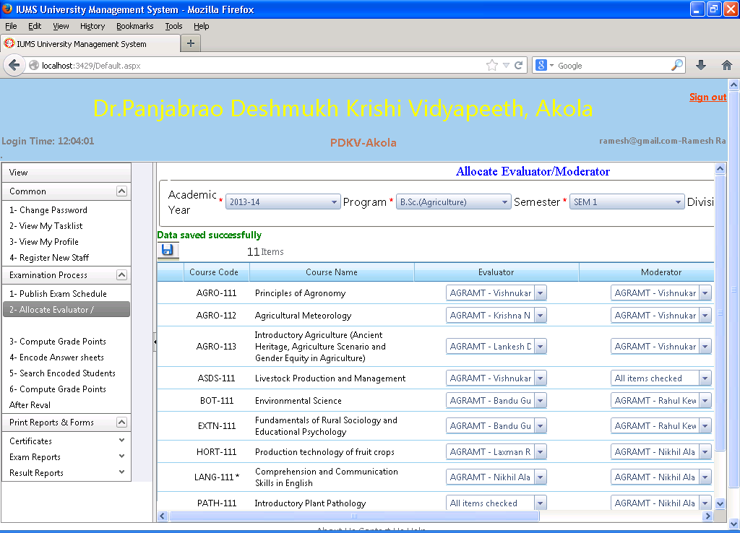

After the final theory exams are conducted, the answer sheets are collected at the CAP center from various exam centers (colleges). The University Exam Dept can allocate evaluator & moderator for each course for checking the papers at the cap center using this screen.

Screen Operation: Select the academic year, program and semester. The list of courses for the semester will be displayed. Select the name of the evaluator and moderator from the drop down lists. Click on Save button to save the data.

4.21 Encode Answer sheets

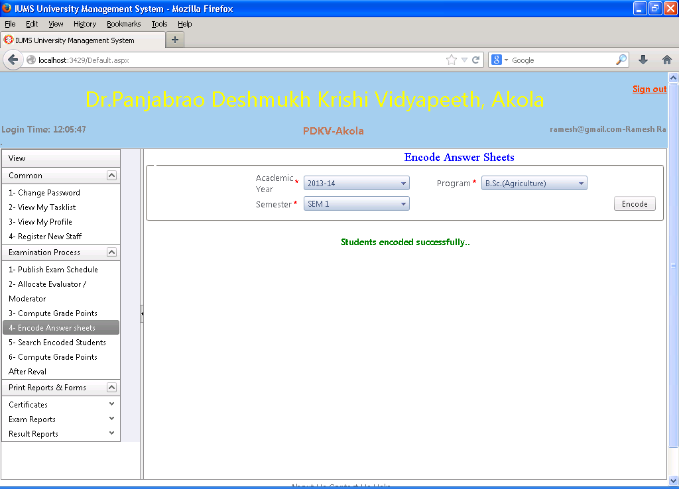

Screen Operation: Select the academic year, program and semester. Click Encode button. All the students across all colleges in the selected program/semester will be assigned encoded numbers for all the course papers.

4.22 Print Encoded Student List

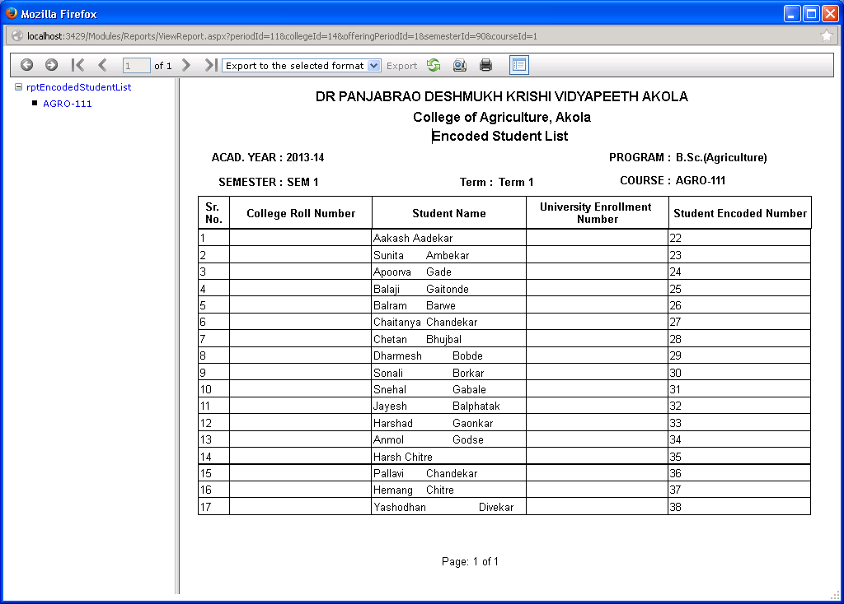

Screen Operation: Select the academic year, program, semester and course. Click the Print button. When Print button is clicked, the report is displayed in a separate window. Click on the Printer icon to print the report. The list shows the students along with the encoded number assigned to them. This report can be used to paste the encoded number on the students answer sheets and hide the student identity from the evaluator/moderator in CAP center.

4.23 Search Encoded Students

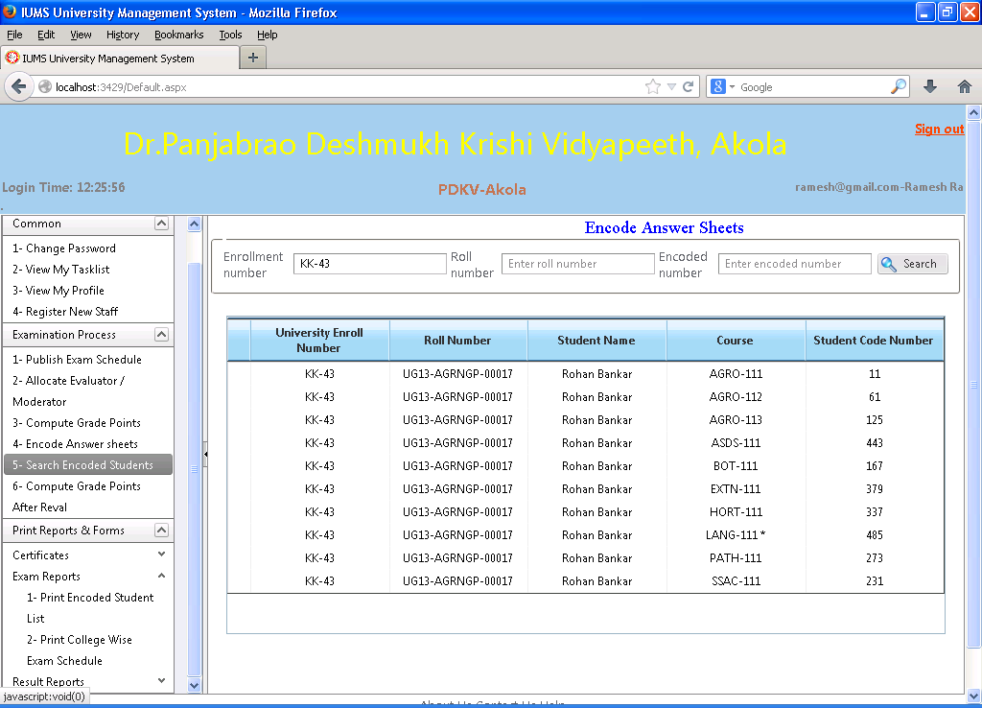

Screen Operation: Input the enrollment no. or the roll no. of the student and click Search button. The student’s encoded number for all the courses will be displayed. By default only the encoded numbers in the current academic year will be displayed.

Conversely you can input the encoding number and click Search button. The student details and course name for which the input encoding number was assigned is displayed.

4.24 Enter Theory Marks

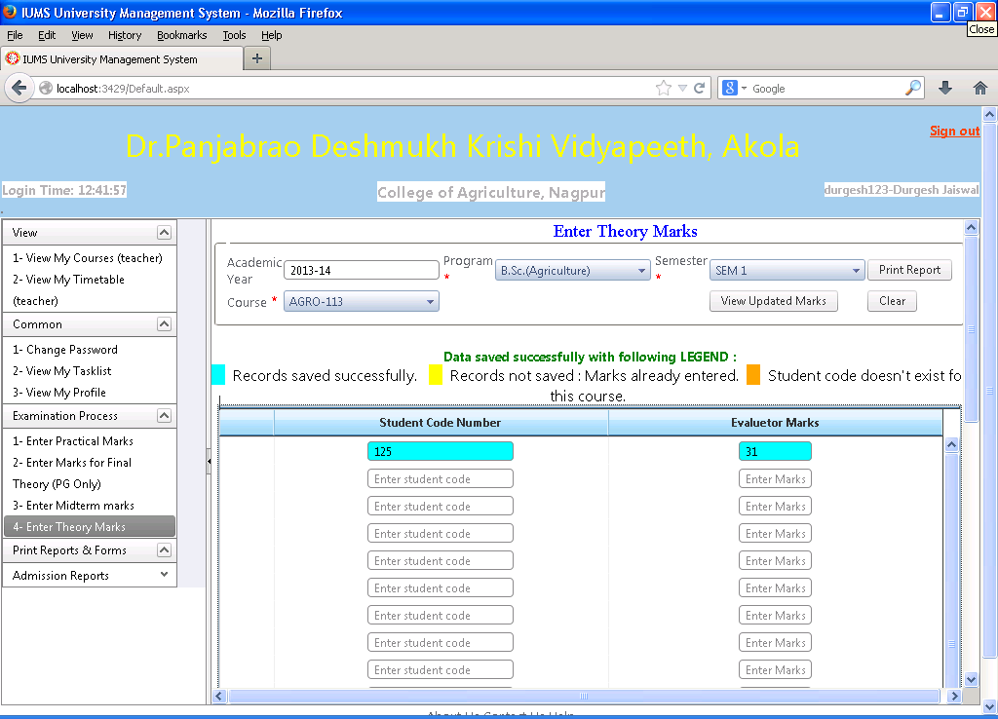

Screen Operation:

This screen is to be used by the course evaluator at the CAP center. The same screen is also used by moderator.

After clicking the menu Enter Theory marks, the CAP center head login screen will be displayed. The CAP center head will have to login with his own user id/password, and then only the evaluator can proceed to enter marks.

After CAP center head has logged in, select Academic year, Program, semester and course.

Input the encoded number on the answer sheet and marks obtained by the student in the text boxes in columns in the lower pane. Click Save button when done.

Click on View Update Marks to view the marks already input or Click on Print Report button to take a print out of the marks input. Check the marks once again. If any mistakes are found, you can correct them. Finally click Save & Submit button to save the marks. Once Save & Submit is clicked, the marks cannot be changed.

The marks records will be highlighted with a color code as shown in the screen. If the Encoding number is wrong, the marks will not be updated and shown in cyan color. If the marks are already entered for a encoding no., the data will not be saved and shown in yellow color. Records successfully saved will be shown in blue color.

Enter Theory Marks (Report)

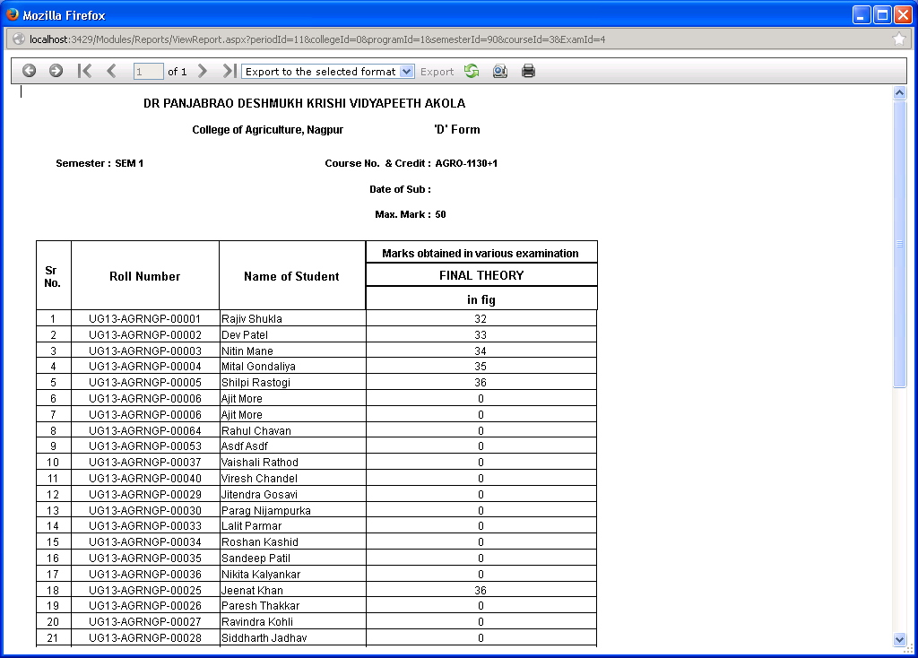

When Print button is clicked, the report is displayed in a separate window. Click on the Printer icon to print the report.

4.25 Moderator Marks Difference Report

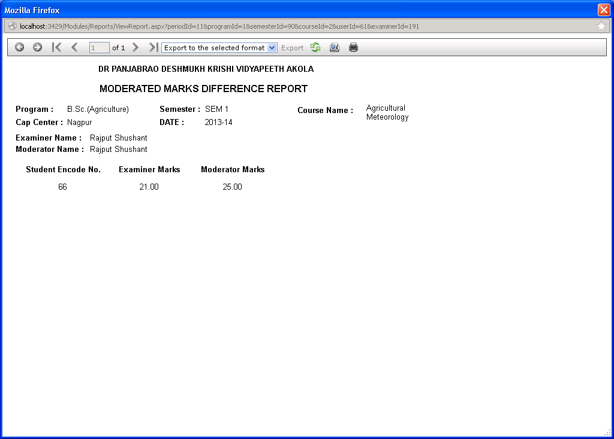

Screen Operation:

This screen is used by CAP center head to compare the marks given by Evaluator and the moderator and if there is any difference, the same is reported.

When Print button is clicked, the report is displayed in a separate window. Click on the Printer icon to print the report.

4.26 Authorize Theory Marks

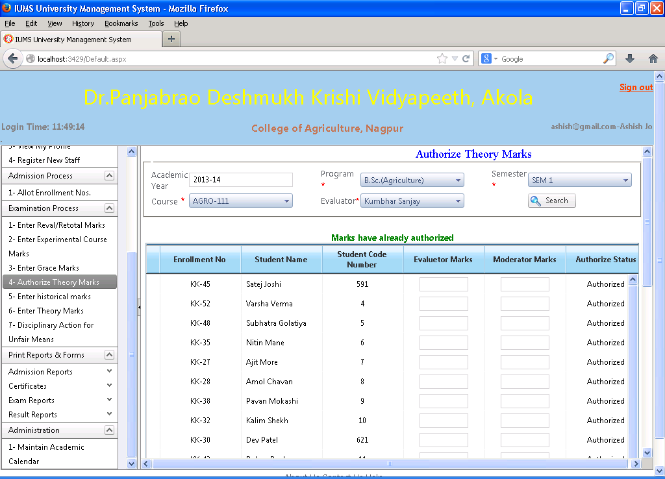

Screen Operation: Select academic year, program, semester, course and the name of evaluator. Click Search. The student’s enrollment no., name , encoding no. and marks given by evaluator and moderator are displayed. Authorization status is also displayed. Click on Authorize button to authorize the marks.

4.27 Enter historical marks

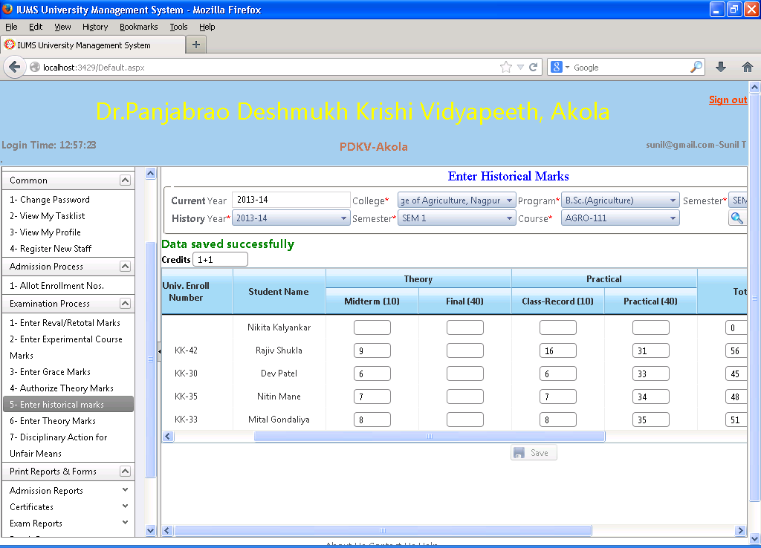

Screen Operation: Select the History year, college, program, semester and course. Click Search button. The list of students registered for that course in the history year is displayed. Input the marks in the respective exam columns like Midterm, Final, Class record and Practical. The total of marks is calculated and displayed. Click on Save button to save the data.

4.28 Enter Experimental Course Marks

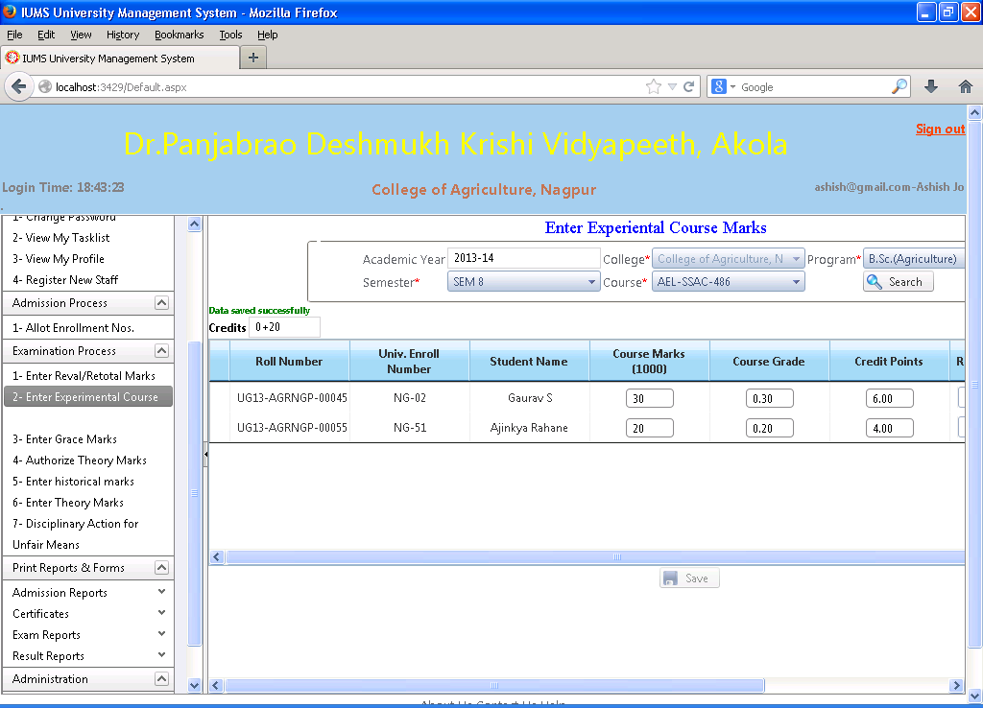

Screen Operation: This screen is used to input marks for courses that have no formal examination but experiential type courses. Select the academic year, program, semester and course. Click on Search button. The list of students registered for that course is displayed. Input the marks in the Course marks column. Course grade, credit points and result will be calculated and displayed. Click Save button to save the data.